What is the purpose of your long run – Jeff Gaudette
The first step to determining long run pace is assessing the purpose and intensity of your long run session.

Not all long runs are created equal.

Some long runs are designed to simulate marathon conditions or teach you how to finish fast. These types of long runs are considered a hard workout and you have extra recovery days scheduled after your session to recover.

On the other hand, some long runs are considered easy. They are meant to be run at an easy intensity to build aerobic endurance and put “time on your feet”.

These types of long runs aren’t exactly recovery runs, but they aren’t designed to be hard either.

Understanding the purpose and desired outcome of your long run is important because long runs are just one piece to the training puzzle.

For example, race specific long runs are an integral part of a training plan and can help take your running to the next level.

However, if your long run is designed to be a relatively easy day and you run too hard, you’ll start your next workout too fatigued and risk poor performance and injury.

What about those easy long runs on your schedule? How fast should they be an why?

What is the optimal pace if your long run is easy?
If your long run is easy – not a specific workout, then what is the optimal pace?

To answer that question, let’s look at some of the physiological benefits of the long run and how each is influenced by pace:

Capillary development
Capillaries are the smallest of the body’s blood vessels and they help deliver oxygen and nutrients to the muscle tissues. The greater the number of capillaries you have surrounding each muscle fiber, the faster you can shuttle oxygen and carbohydrate into your muscles.

Capillary development appears to peak at between 60 and 75 percent of 5k pace.

This isn’t to say that running really slowly or much faster on occasion doesn’t have any benefit. However, running much faster or slower than this pace doesn’t significantly increase or decrease capillary development.

Increase myoglobin content of muscle fibers
Myoglobin is a special protein in your muscles that binds the oxygen that enters the muscle fiber. When oxygen becomes limited during exercise, myoglobin releases the oxygen to the mitochondria. Simply speaking, the more myoglobin you have in your muscle fibers, the more oxygen you can sequester to the muscle under aerobic duress – like during a race.

While all muscle fibers contain myoglobin, the ones we’re most concerned with targeting during the long run are the Type-I (slow twitch) muscles. Research has shown that maximum stimulation of Type I muscle fiber occurs at about 63-77 percent of VO2max. 63-77 percent of VO2max is about 55-75 percent of 5k pace.

Increasing Glycogen storage in the muscles
Glycogen is how the body stores carbohydrates in the muscles for usable energy. While this isn’t important for races that last under 90 minutes, when racing the marathon, the more glycogen you can store in your muscles, the longer you can prevent the dreaded bonk.

The goal with easy long runs is to deplete the muscles of their stored glycogen. The body responds to this stimulus by learning to store more glycogen to prevent future depletion.

The faster you run the greater the percentage of your energy will come from carbohydrates. While there isn’t any scientific research on the optimal pace that burns significant carbohydrate while still providing enough energy to get through a long run, experience and the study of elite runners has shown that a pace of about 65-75 percent of 5k pace is optimal.

Mitochondria development
Mitochondria are microscopic organelle found in your muscles cells that contribute to the production of ATP (energy). In the presence of oxygen, mitochondria breakdown carbohydrate, fat, and protein into usable energy. Therefore, the more mitochondria you have, and the greater their density, the more energy you can generate during exercise, which will enable you to run faster and longer.

Two researchers, Holloszy (1967) and Dudley (1982) published some of the defining research on optimal distance and pace for mitochondrial development. In short, Holloszy found that maximum mitochondrial development occurred at about 2 hours of running at 50-75 percent of V02max. Likewise, Dudley found that the best strategy for slow-twitch, mitochondria enhancement was running for 90 minutes per outing at 70 to 75 per cent V02 max.

Summing it all up
That’s a lot of research, percentages and numbers. If you’re not as analytically inclined as I pretend to be, here is a neat chart to sum up the research: 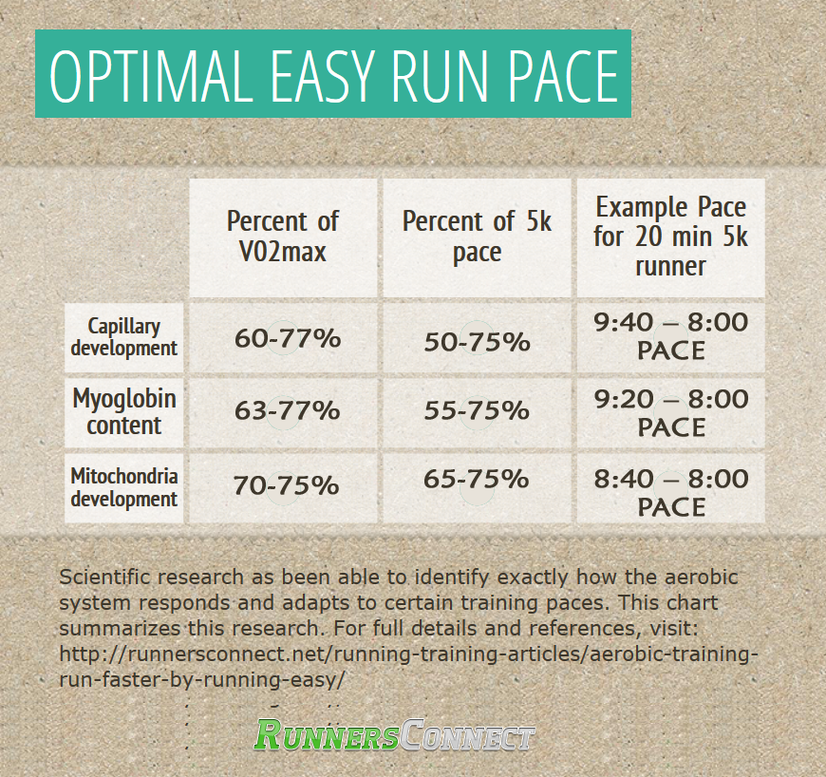

The body of evidence is clear, your optimal long run pace is between 55 and 75 percent of your 5k pace, with the average pace being about 65 percent.

It’s also evident from this research that running faster than 75% of your 5k pace on your long run doesn’t provide a lot of additional physiological benefit.

Therefore, pushing the pace beyond 75% of 5k pace only serves to make you more tired and hamper recovery.

In fact, the research indicates that it would be just as advantageous to run slower as it would be to run faster.

50-55 percent of 5k pace is pretty easy, but the research clearly demonstrates that it still provides near optimal physiological benefits.

If you’re feeling tired and the long run isn’t scheduled to be a hard day, don’t be afraid to slow your long run down. My suggestion is to start on the slower side of the pace recommendations (50% of 5k pace) and slowly pick it up through the run if you feel good.

