Track Sessions
Purpose:
Track sessions are designed to build the body’s anaerobic system resulting in improved running economy, faster foot speed and a reduction in injury.
General Information:
https://www.richmondmarathon.org/marathon-training-team/resources/speed-workouts/
Track Length:
1 lap = 400m
2 laps = 800m
3 laps = 1200m
4 laps = 1600m
6 laps = 2400m
8 laps = 3200m
Warm ups (1 mile easy run) including dynamic drills (listed below) are performed prior to starting.
Warm ups begin at 5:30 – 5:45pm. Track intervals start promptly at 6pm (sooner if the track is free and warm ups complete).
Cool downs are performed after the last interval.
Ample amounts of water and electrolyte drinks should be brought and consumed during track sessions.
Intervals should be run as close to inside lane 1 as possible but allowing faster runners to utilize lane 1 when passing.
If you do plan to utilize another lane for your fast intervals, here is the length for 1 lap – lane 2 = 407m, lane 3 = 415m, lane 4 = 423m.
Recovery intervals can be performed by walking / jogging in outside lanes clockwise.
Recovery intervals – 400m – Roughly 1 – 1.5x the amount of time it took to perform fast interval, 600m – 1200m – roughly 3 minutes, 1600m – 3200m – up to 5 minutes of recovery - ** Note these are estimates, take enough time to recover and start the next fast interval avoiding taking too much time.
We will run in the rain if need be. We will not run in a thunderstorm (will delay the track session if possible for storms to pass before cancelling).

Dynamic Drills (performed 10-15 yards each):
Skipping
Golf ball pick ups
Karaokes
Straight Leg Marching
Leg Swings (Front/Back and Side/Side)
Knee to chest
Butt Kicks
Strides (100m starting off slow and building to 90% effort)
What you need to do:
Look up the track session spreadsheet (Track Workouts) for the workout of the day - https://www.richmondmarathon.org/marathon-training-team/resources/speed-workouts/
Verify the location, date and time of track session - https://www.richmondmarathon.org/marathon-training-team/resources/speed-workouts/
******* All interval times are guidelines. Each athlete should be able to perform each fast interval at a pace they can maintain throughout the workout WITH good form. Adjust your times slightly as needed *******

Example: My goal is to run a 4:30:00 marathon in Richmond. I ran
Patrick Henry Half Marathon in 2:10:00

Go to https://www.mcmillanrunning.com/

STEP 1: Choose Half Marathon and input your goal Half Marathon time
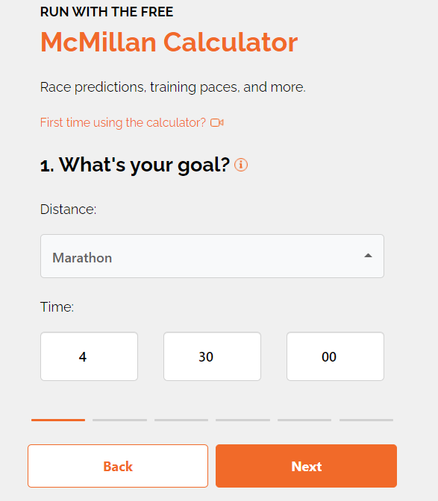

STEP 2: Enter your experience level.
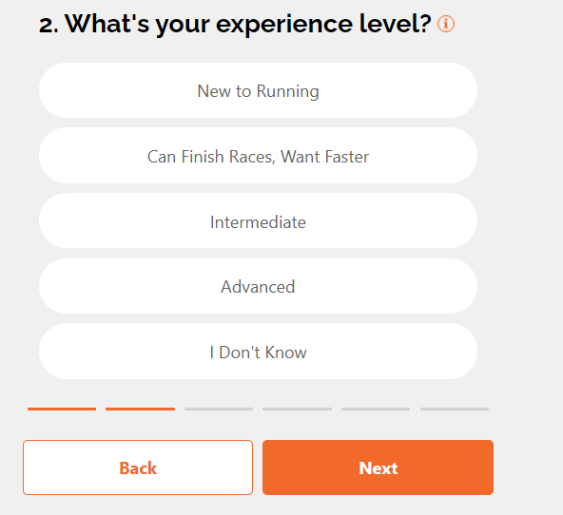
STEP 3: Enter your runner type.
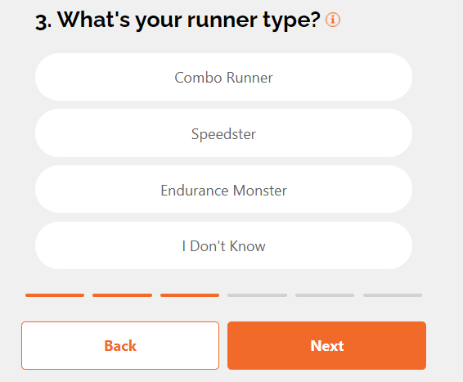

STEP 4: Enter in a very recent distance and time, preferably a distant event (a PR from 1 year ago is not suitable and will not provide accurate splits).
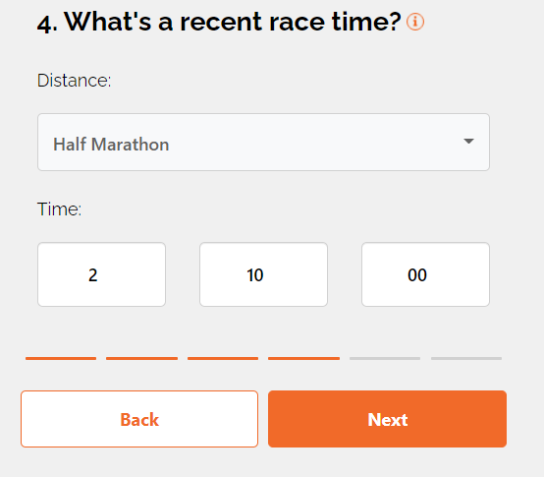

STEP 5: Choose pace unit
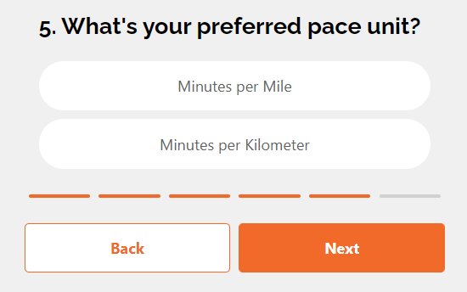

STEP 6: Click Calculate – you do not need to enter your name or email address
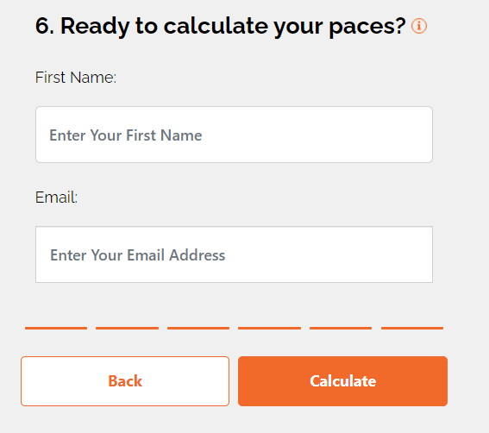
Click on “Training Paces”
Scroll down to “Speed Paces” to obtain your track paces under “Endurance Monster”. They are listed in the ( x:xx - x:xx ). In this example, the interval pace to run the 400m is the (1:57-2:05) range and the pace you will be running is 7:53 – 8:23.
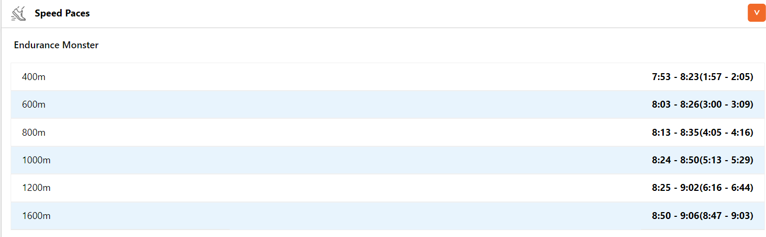

Bring your pace chart with you to the track.

Recap:
- Look up and print our pace time.
- Look up track dates / times.
- Check weather if need be. We will wait out a storm or pause a track workout in the event of thunder / lightening.
- Bring watch, towel, water, electrolyte drink, running shoes.
- Show up to track and start warming up (5:30pm) – 1 mile easy run plus dynamic drills plus 2 -4 strides
- Perform intervals at your current level.
- Cool down.
- Go home happy.

Other good calculator resources:
http://www.glrr.net/images/track/PacingCharts/PaceChart.pdf
https://www.gulfwinds.org/ , click on training and click on “track Interval Pace Calculator”

