
Track Sessions
Purpose:
Track sessions are designed to build the body’s anaerobic system resulting in improved running economy, faster foot speed and a reduction in injury.
General Information:
https://www.richmondmarathon.org/marathon-training-team/resources/speed-workouts/
1 lap = 400m
2 laps = 800m
3 laps = 1200m
4 laps = 1600m
6 laps = 2400m
8 laps = 3200m
Warm ups (1 mile easy run) including dynamic drills (listed below) are performed prior to starting.
Warm ups begin at 5:30 – 5:45pm. Track intervals start promptly at 6pm (sooner if the track is free).
Cool downs are performed after the last interval.
Ample amounts of water and electrolyte drinks should be brought and consumed during track sessions.
Intervals should be run as close to inside lane 1 as possible but allowing faster runners to utilize lane 1 when passing.
If you do plan to utilize another lane for your fast intervals – lane 2 = 407m, lane 3 = 415m, lane 4 = 423m.
Recovery intervals can be performed by walking / jogging in outside lanes clockwise.
Recovery intervals – 400m – Roughly 1 – 1.5x the amount of time it took to perform fast interval, 600m – 1200m – roughly 3 minutes, 1600m – 3200m – up to 5 minutes of recovery - ** Note these are estimates, take enough time to recover and start the next fast interval avoiding taking too much time.
We will run in the rain if need be. We will not run in a thunderstorm.

Dynamic Drills (performed 10-15 yards each):
Skipping
Golf ball pick ups
Karaokes
High Skipping
Flat-Footed Marching
Straight Leg Marching
Leg Swings (Front/Back and Side/Side)
High Knees
Quick Feet
Butt Kicks
Strides (100m starting off slow and building to 90% effort)
What you need to do:
Look up the track session spreadsheet (Track Workouts) for the workout - https://www.richmondmarathon.org/marathon-training-team/resources/speed-workouts/
Verify the location, date and time of track session - https://www.richmondmarathon.org/marathon-training-team/resources/speed-workouts/
******* All interval times are guidelines. Each athlete should be able to perform each fast interval at a pace they can maintain throughout the workout WITH good form. Adjust your times slightly as needed *******

Go to https://www.mcmillanrunning.com/ and input your goal marathon time in step 1 (this goal needs to be reasonable). Step 2, enter in a very recent distance and time, ie: Patrick Henry Half Marathon time would be perfect or use a very recent time, preferably a distant event (a PR from 1 year ago is not suitable and will not provide accurate splits). Click “Calculate My Paces”.

Example: My goal is to run a 4:30:00 marathon in Richmond. I ran
Patrick Henry Half Marathon in 2:10:00
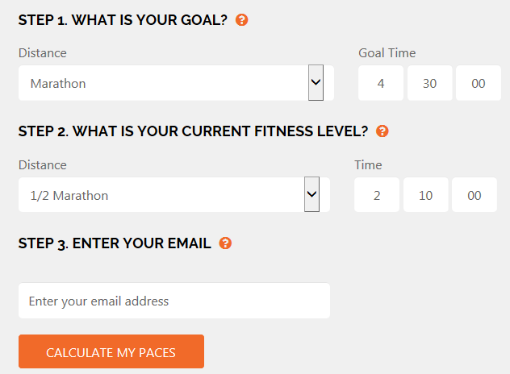

Click on “Training Paces” in the top left.


Scroll down to “Speed Paces” to obtain your track paces. They are listed in the ( x:xx-x:xx ). In this example, the interval pace to run the 400m is the (1:57-2:05) range.
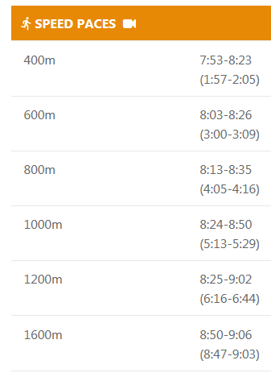

Bring your pace chart with you to the track.
To obtain your 2400 interval time, take the higher value of your 800m + higher value of your 1600 = 2400 interval time. To obtain your 3200 interval times, take the higher value of your 1600m x 2 = interval time. ** These times will be the faster end of your 2400 and 3200 intervals **
Example above – 4:16 + 9:03 = 13:19 – 14:00 for 2400m
Example above – 9:03 x 2 = 18:06 – 19:00 for 3200m

Recap:
- Look up and print our pace time.
- Look up track dates / times.
- Check weather if need be.
- Bring watch, towel, water, electrolyte drink, running shoes.
- Show up to track and start warming up (5:30pm) – 1 mile easy run plus dynamic drills plus 2 -4 strides
- Perform intervals at your current level.
- Cool down.
- Go home happy.

Other good calculator resources:
http://www.glrr.net/images/track/PacingCharts/PaceChart.pdf
https://www.gulfwinds.org/ , click on training and click on “track Interval Pace Calculator”

